**The Strangemen IV Investment Club (HBHXX74T) - may have changed TBC**

Minutes of the twenty fifth meeting - Held Wednesday 30th October, 2019 at The Mill Street Club, Mill Street, Leek.

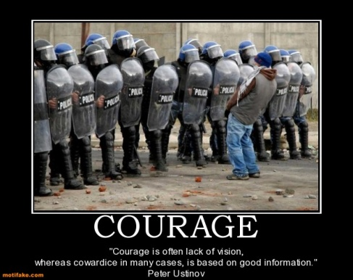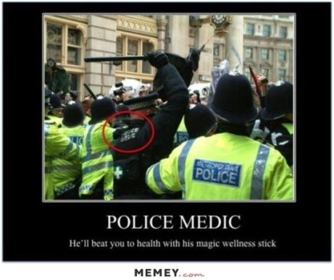

|  |  |
| --- | --- |
| Attendees:   * James Taylor (JT) , Mike Helm (MH), Neil C Pickford (NCP), Dave Swarbrook (DS), Gareth "Bloody" Ekin (GE), Alan Whitmore (AJW), Dave McNeaney (DMcN)   Apologies:   * Dean Goodwin (DG) - away with the non fairies * Sri Madadi (SM) - cruisin, but not for a bruisin'! * Andy Bradley (AMB) – in the Matrix * Matt Culverwell (MC) - badger wrangling? * Emma Chadwick (EC) - badger wrangling? * Newton (the guffin's dog) - probably not badger wrangling * Jes Challand (JC) - "L’enfer, c’est les autres". This month, Jes shares his initials with Junior Campbell, founding member, lead guitarist, piano player, and singer with the Scottish band **Pictured_in_May_2016.jpg** | |
| **Agenda:**   * 1. Previous Actions   2. Treasurers Report  1. Current Share Update 2. Current Digital Update 3. Financial Statement 4. Dividends    1. Homework (Current Portfolio)    2. Strategy for New Investment 5. New Companies 6. Re-investment in Existing Portfolio    1. Fantasy Shares    2. Peston    3. AOB    4. Next Meeting | |
| 1. Okay Previous Minutes What, there were minutes - no way - seriously, does anyone read this ***There are more trees on earth than there are stars in the galaxy.*** NASA estimates that there are between 100 billion and 400 billion stars in the Milky Way galaxy. And according to a paper in Nature, there are more than 3 trillion trees on Earth. |  |
| **2. Previous Actions**  **2.3.1** - NCP to email TDW re: currency error on account and what is needed to trade in US - Info received but memberships require sorting with TDW - back to NCP - NCP to grab papers. **Written to by hand with a request for info!**  **22.4.3.2** - JT to chase House Crowd for profit details - awaiting 3 properties to be sold. - just 1 property left now.  **24.3.2.1** £470.56 in Crypto currencies. It was agreed to take £250 profit - MC to be asked to transfer to JT - to do  **24.3.3.2** - JT agreed to add a column for individual share purchase price - book cost/ shares held - to do  **24.5.1.1 -** £750 each of Sirius and Next I5 to be purchased. - This was done.  **24.8.1 -** Xmas do - date set 9th November - Sri looking at venues, to accommodate our vegan and vegetarian members. - Al's Wedding is the new Xmas do! | **NCP**  **JT**  **MC/JT**  **JT**  **ALL** |
| **3. Treasurers Report**   1. **Current Share Update**  |  |  |  |  |  |  |  |  |  |  |  | | --- | --- | --- | --- | --- | --- | --- | --- | --- | --- | --- | | **Symbol** | **Qty.** | **Description** | **Champion** | **Mid Price** | **Price Change** | **Market Value** | **Book Cost** | **Gain/Loss** | **Prev Month** | **Variance** | | ASC | 28 | ASOS PLC | DG | 3512.00p | -54.00p | 983.36 | 976.63 | 6.73 | 983.36 | 0 | | CDM | 438 | CODEMASTERS GROUP | DS | 218.00p | 2.00p | 954.84 | 999.95 | -45.11 | 941.7 | 13.14 | | HAYD | 3312 | HAYDALE GRAPHENE INDUSTRIES PLC | JT | 1.45p | 0.00p | 48.02 | 557.52 | -509.5 | 58.79 | -10.77 | | IMMO | 3935 | IMMOTION GROUP | DG | 7.35p | -0.50p | 289.22 | 499.91 | -210.69 | 267.58 | 21.64 | | MNG | 48 | M&G PLC | DG | 213.00p | -3.00p | 102.24 | 106.81 | -4.57 | 102.24 | 0 | | MERL | 262 | MERLIN | DMcN | 454.60p | -0.20p | 1191.05 | 997.71 | 193.34 | 1181.62 | 9.43 | | NFC | 125 | NEXT FIFTEEN COMMUNICATIONS |  | 492.50p | 7.50p | 615.63 | 746.2 | -130.57 | 615.63 | 0 | | PRU | 48 | PRUDENTIAL | DG | 1366.50p | -13.50p | 655.92 | 749.34 | -93.42 | 688.32 | -32.4 | | PURP | 148 | PURPLE BRICKS | AJW | 113.40p | 0.40p | 167.83 | 747.41 | -579.58 | 177.9 | -10.07 | | RAI | 916 | RA International | MH | 38.50p | 0.00p | 352.66 | 499.88 | -147.22 | 444.26 | -91.6 | | SXX | 8345 | SIRIUS MINERALS | SM | 2.98p | -0.05p | 248.51 | 750 | -501.49 | 248.51 | 0 | | SMDS | 204 | SMITH(DS) | NCP | 357.50p | -3.90p | 729.3 | 747.72 | -18.42 | 654.43 | 74.87 | | SUMO | 432 | SUMO GROUP | AJW | 155.00p | -1.50p | 669.6 | 748.72 | -79.12 | 699.84 | -30.24 | | TSTR | 1156 | TRI-STAR RESOURCES | SM | 31.00p | -1.00p | 358.36 | 750 | -391.64 | 421.94 | -63.58 | | VRS | 547 | VERSARIEN | JT | 93.50p | -0.50p | 511.45 | 999.74 | -488.29 | 585.29 | -73.84 | | VOD | 372 | VODAFONE | SM | 157.54p | -0.66p | 586.05 | 749.37 | -163.32 | 554.35 | 31.7 | | FAN | 410 | VOLUTION | NCP | 197.00p | 2.00p | 807.7 | 748.31 | 59.39 | 725.7 | 82 |  1. **Current Digital Update**   **25.3.2.1** £383.52 in Crypto currencies.   1. **Financial Statement**   **25.3.3.1** - The club has cash of £9,146.42. Cash at Barclays is approx £720.32**.** £1110 each in 37 units, now worth £1175.11. Sold Boohoo for £1,151.65 on 9/9. Bought £746.20 Next15 19/8, £750 Sirius Minerals 19/8, £976.63 Asos 21/10     1. **Dividends**   **25.3.4.1** 26/9 - Pru = £7.89.    **4. Homework (Current Portfolio)**  Areas of focus - owners - Aerospace & Defense – AJW, Automobiles & Parts – EC, Electronic & Electrical Equipment – DMcN, Gas, Water & Multi Utilities – DSW & AJW, Health Care Equipment & Services – EC & NCP, Mining – JT, Mobile Telecommunications – MC, Pharmaceuticals & Biotechnology – DSW & JT & NCP, Software & Computer Services – MC, Travel & Leisure – DMcN  Codemasters - slight increase in sales. Digital sales risisng. Haydale - new materials with BAE for planes and lightning. M&G - new split from Pru entity. Merlin - Theme park in Blackpool? Purplebricks - not for sale says chairman - US and AUS businesses gone. Smith DS -new recyclable packaging deal with Morrisons - premier bacon. Deal with the FSC. Sumo - slight buy recommendation. Versarien - still tipped long term - early days of tech. Volution - revenue up 14% and a few acquisitions.  **5. Strategy for New Investment**   1. **New Companies**   **25.5.1.1 -** Discussions about win pre-orders and BritBox - streaming from ITV/ BBC. No purchases.  **2. Re-investment in Existing Portfolio**  **25.5.2.1 -** No additional re-investment purchases  **6. Fantasy Shares**  **Pinned - 24.6.1 -** Agreed to revert to old style. Probably September 2019 meeting. Still to re-start  **7. Peston**  Elderly woman from France was throwing out painting worth 24mn Euros. a US woman had to pay her hubby compensation of $5,800 so paid him in dimes. Police confused in USA, as women hits deer in crash, but there was far too much blood - she was returning from a Halloween party, dressed as Carrie. Irish man plays prank at funeral by having voice recording of him asking to be let out of the coffin. A man in a Pennsylvania half-way house ordered and had delivered 2 grams of enriched uranium. Hasmat called. A man had 5 inches deep of fat and blood in his basement, leaking in from meat locker next door. Equadorian company launches guinea pig flavoured ice-cream. 50ps to celebrate 31/10 Brexit have all been re-smelted. A pic was shown of Osama Bin-Laden's face in a seashell. Man had tweezers stuck in urethra for 4 years. A German dentist extracted a tooth from a Croatian man that was 4cm long! A Glaswegian man was stopped by POlice as he had 4 settees strapped to the root of his car. A Russian man is suing Apple, as he claims that his iPhone turned him gay, as he managed to mistakenly buy Gaycoin, not Bitcoin. USA Police found a 5 year old had driven his small toy tractor to a local garage, as he needed oil. Couple discovered their car bonnet full of nuts and grass, as a squirrel had been using it as a winter store.  **8. AOB**  **PInned - 24.8.1 -** Xmas do - date set 9th November - Sri looking at venues, to accommodate our vegan and vegetarian members. - Al's Wedding is the new Xmas do!  **9. Next Meeting**  Wednesday 4th December, 2019. Usual Venue at 8.15. It was decided to just muck in on pizza payment - it is soooo much easier that way!  **Side Note - Pizza area for future reference - 18" (254.24") - 14" (153.93") - 12" (113.09") - 9" (63.61")**  “Hell is other people.” - Jean-Paul Sartre | **All**  **All** |