The Strangemen III.0 Investment Club (8N93KW6E)
Minutes of the sixth meeting - Held Wednesday 24th July 2013 at The Mill Street Club, Mill Street, Leek.
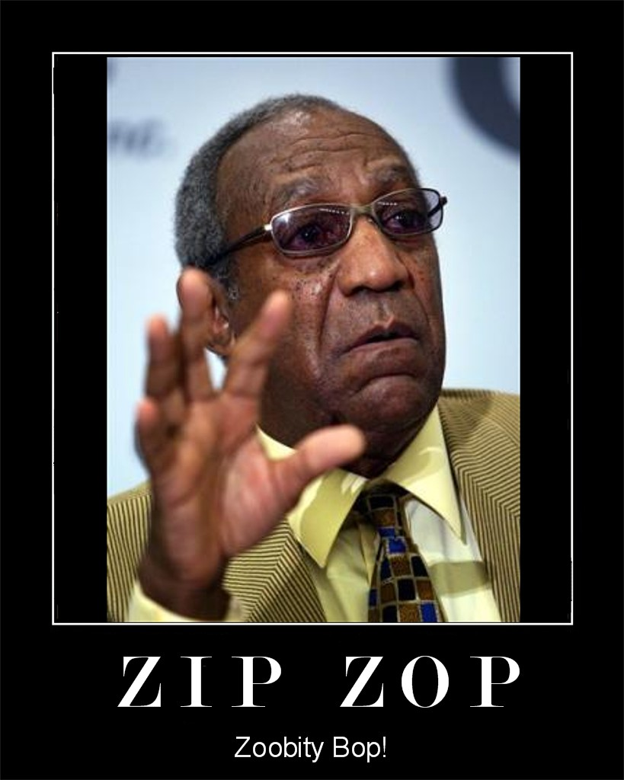
Say it all really!

This month, pics of that start with a "z"
Attendees:
- James Taylor (JT)
- Neil Pickford (NCP)
- Alan Whitmore (AJW)
- David Swarbrook (DS)
- David McNeaney (DMcN)
- Andrew Bradley (AMB)
- Sridar Madadi (SM)
- Matt Culverwell (MC) - breaking his share club hymen - again! (reconstructive surgery obviously!)
- Gareth Ekin (GJE) - no word of a fricking lie!
Apologies:
- Alan Whitmore (AJW) - Work - while he still can!
- Mike Helm (MH) - Hospital appt - honest - he had a note and everything!
- Jes Challand (JC) – Real proper francophile now! ....and bugger me, his initials are the same as overly expensive ladies shoe maker Jimmy Choo.
Agenda:
  - Okay previous minutes
  - Actions
  - Treasurers Report & current portfolio update
  - Investment strategy & Homework (share updates)
  - Fantasy Shares
  - Peston
  - AOB
8. Next Meeting
1. Okay Previous Minutes
Yay!
2. Actions  1.3.1 - Matt C to be registered with TDW - NCP to sort - got the form, will do when Matt has a real house c/f -to pick up when audited by TDW same for 1.7.2 - remove next time  1.7.2 - TDW needs updating - memberships - done barring Matt C  4.7.1 - Mike to arrange a social - possibly in Stone - and invite Glynn and get a hint if Jes is around - maybe even arrange something around his availability (if any)? - James to contact Glynn, Neil P to contact Jes - Glynn yes, Jes "Angleterre? Non." - JT to create as an objective for MH  4.5.1 - Meeting 5 - Sabmiller, Bunzl, Thomas Cook, moneysupermarket, ultra electronics - also Merlin IPO in 2014 - Andy B to look into pre-registration - No sign of pre-reg for Merlin IPO - but AMB will keep eyes open! | NCP  MH  AMB
3. Treasurers Report & current portfolio update
£880.47 in TDW, £comp money in Barcs.
Meeting 5 |  | Meeting 6 |  | Meeting 7
Total Value of new Share Club | £3,748.26 | Total Value of new Share Club | £3,819.97 | Total Value of new Share Club | £4,354.61
Units owned by original mems | 121 | Units owned by original mems | 132 | Units owned by original mems | 143
Units per orig mem | 11 | Units per orig mem | 12 | Units per orig mem | 13
Total original Share Club input | £3,630.00 | Total original Share Club input | £3,960.00 | Total original Share Club input | £4,290.00
Each original member input | £330.00 | Each original member input | £360.00 | Each original member input | £390.00
That is now worth | £340.75 | That is now worth | £347.27 | That is now worth | £395.85
Percentage increase | 3.26 | Percentage increase | -3.54 | Percentage increase | 1.51
Total number of units | 121 | Total number of units | 132 | Total number of units | 143
One unit is worth | £30.98 | One unit is worth | £28.94 | One unit is worth | £30.45

4. Investment strategy & Homework (share updates)
Share | Champ | Value Now | Change in Value from bought | Value Last Month | Previous Change
Vodafone | Mike | 1870.17 | 73.14 | 1752.81 | n/a
Aviva | James | 606.04 | 6.52 | 559.35 | -40.17
ARM | Dave S | 524.22 | -69.05 | 492.94 | -100.33
Randgold | Alan | 473.70 | -88.67 | 464.40 | -97.97
Homework:-
Vodafone - n/a Mike Fail
Aviva - new CEO having a tidy up
Randgold - both gold and silver prices down
ARM - no new info - recommended as Hold

Meeting 2 - Voted on shares - Vodafone, Aviva, ARM, RBS, RANDGOLD, Thomas Cook, SPH
Meeting 3 - Voted on Vodafone, Tesco and Next
Meeting 4 - Voted on Arm, Thomas Cook, Thorntons, Moneysupermarket.com, Ocado
Meeting 5 - Sabmiller, Bunzl, Thomas Cook, moneysupermarket, ultra electronics, Merlin IPO in 2014
Meeting 6 - nowt, but Alan listed good divi payers - HSBC, Shell and BP
Meeting 7 - Tate & Lyle, Barclays
5. Fantasy Shares
James T bags the points with Thomas Cook up 19.76%, but Sri still overall winner, 6 points clear of second place Neil P

Staring into the Co-operative's big black abyss this month;-
July | SHARE | EPIC | START PRICE
Dave S | ARM | ARM | 860.00
Gareth E | Man Group | EMG | 87.50
Mike H | Thorntons | THT | 86.00
Neil P | JD Wetherspoons | JDW | 748.00
James T | Thomas Cook | TCG | 150.20
Matt C | Cyprotex | CRX | 6.00
Andy B | Alent | ALNT | 360.00
Jes C | Marks and Spencer | MKS | 483.00
Dave McN | Diageo | DGE | 2015.00
Glynn G | Punch Taverns | PUB | 13.50
Alan W | ElectroComponents | ECM | 251.00
Sri M | Apple ($) | AAPL | 440.70
Narayan | Lloyds | LLOY | 69.28

6. Peston
n/a
7. AOB
7.7.1 - MC tabled the idea to club together and buy houses-or become landlords!
8. Next Meeting
TBC 2013 at Mill Street Club, 210 Mill Street – then curry.

